“Improvement in the Rural School Environment”

**Team name: Edu-Bridge**

**Theme: Education**

**Team leader & members:** Ch.Haarika(L)

Ashish Kumar

P.Rachana

K.Swarnamika

**Mentor’s Name:** Mrs.Sailaja

**Institute Name & Address:** Aditya college of Engineering & Technology,

Aditya Nagar, Surampalem, ADB road, East Godaveri,Andhra Pradesh,533437.

**Title of the Innovation Proposal:** “Enhancing the Basic Education”

**Project Description:**

**PROBLEM :**

During the year 2015-2016 student’s enrolment in to government schools across 20 Indian states had fell by 13 million , while private schools acquired 17.5 million new students. The main reason for this down fall is lack of good infrastructure, teachers, facilities and delay in government response. To resolve this problem, the government is taking some steps and instructing the MEO’s and DEO’s regularly in this regard. But this communication is going through letters which consumes much time in implementation and also increases paper work.

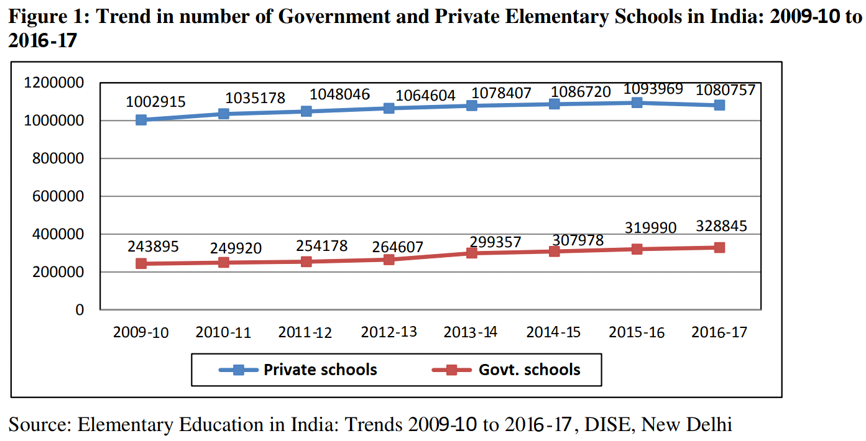

**SOLUTION:**

The solution for this problem is using less time consuming media to send the information. For that planning to do a website which takes the information regarding infrastructure from the school Head Master(HM) or Incharge Head Master(IHM) and send it to the Mandal Educational officer (MEO). If the problem isn’t resolved in 15days, it automatically sends to and District Educational officer (DEO). As a result, the information can be reached in accurate time and the government can also view the information when ever required and respond according to it. 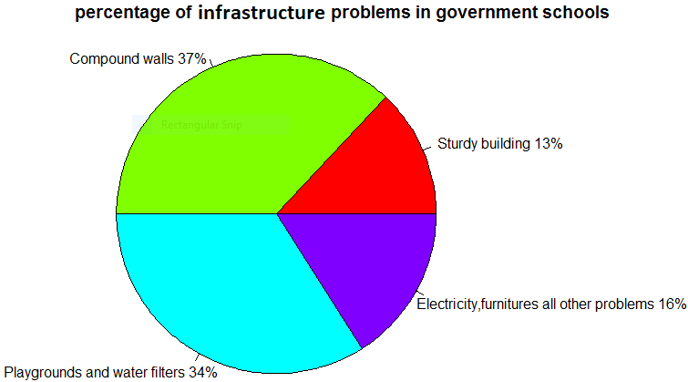

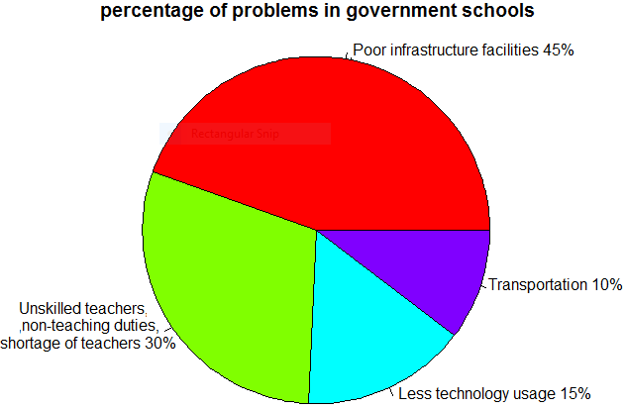

**TECHNOLOGIES USED:**

To develop our website, we’re going to use MEAN stack majorly.

Because making use of cluncky and uncoordinated development tools leads to poorly developed web applications. To produce elegant application, we need strong alies like database systems, frontend frameworks, libraries and servers. MEAN stack is one such technology, which is considered one of the best for website development. It’s a free and open source Java script software stack. It allows the users to develope efficient isomorphic code. The database used is MongoDB which itself improves the flexibility of MEAN stack.

The main purpose for using MEAN stack is its time saving. As we know that we have to prepare our website in limited time. So we choosed MEAN Stack. Along with MEAN stack, the minor technologies used are HTML,CSS.

To create our website, more efficiently we need CSS scripts which gives an elegant look to it. So, we’re going to use CSS & HTML.

**TARGET BENEFICIARY:**

As today's children are tomorrow’s citizen,we focused on the students for the development of the country.Away from home,schools become the place for students to spend their maximum time.So,schools need to provide them good environment to make them feel free and interested to learn.

Our website's main aim to provide the students with all the infrastructure which they deserve They don’t need to compromise with the infrastructure which is less than they need.It is possible through our website.Although,government is providing more funds for the development of educational institutions,many schools don’t have the proper infrastructure.This happens because of misuse of funds by some people.

So,we are developing a website which directly connects the Head masters of government schools with the respective Mandal Education Officer(M.E.O) and District Education Officer(D.E.O).So that the funds are used effectively.Thus,it is beneficial to government to avoid the misuse of funds by some useless persons and to students to learn effectively with the required.Meanwhile it is reducing paperwork as all the process is done on Internet.Total time to pass the problem's information to higher authorities and getting the help is reduced.

**DELIVERY MODEL:**

Finally we are delivering the product in software model like website our target beneficiary is to use the website in every government school and to improve infrastructure. Thus it attracts the students . And people will get the quality education with low price.

**CONCLUSION:**

Present in government schools students getting the quality education through digital classes. But the reason for low strength is not having the rooms and learning spaces in good condition. The fact is that a good school infrastructure with renewed spaces makes it possible for children to improve there performance. We providing the solution for this problem through our website.

**Signature:**

**(**Ch.Haarika(L)**)** (Ashish Kumar) (P.Rachana) (K.Swarnamika)

**Declaration:** I hereby declare that all the above information furnished herein by the team is true to the best of my knowledge. I understand and accept that our application for the contest may becancelled in case the above declaration is found to be false.

Date: (Mrs.Sailaja)

Place: